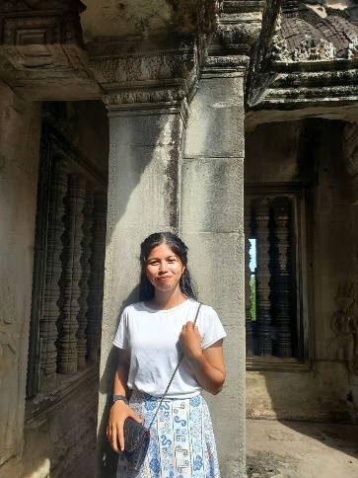

MAO PHEAKTRA

A creative and collaborative digital marketing with over 15 years of experience. Expert in driving growth and raising brand awareness through customer-centric campaign strategies. Specialzes in cross-channel marketing, digital communication, and social media management.

Work experience

* Senior digital Marketing Specialist

Activate Media Advertising

August 2018 to present

Implements cross-channel media marketing and advertising campaigns, responsible for handing B2B and B2C client marketing campaigns, from planning to optimization.

* Digital Marketing Specialist

Sierrawood Art Collectors

January 2012 to 2018

Developed and executed digital marketing content strategies, Increased organic site traffic by 79

* Sales and Marketing Assistant

Vandemar construction

July 2010 to December 2011

Worked on sales proposals and direct mail marketing campaigns, Coordinated trade shows and events.

Skills and Proficiencies

* Fluent in Spanish and Chinese
* Copywriting and editing
* Search engines and optimization (SEO) and Search Engines Marketing (SEM)

S

Educational Background

* De Loureigh University

Venston Bay

Master’s degree in Digital Marketing

2017

Magna Cum Laude

* Croalstead Institute of Technology

Bachelor’s Degree in Marketing

2010

Best Thesis: Analyzing the Role of

Social Media in Intergrated Marketing Communications.

Volunteer Work

* Volunteer social Media Coordinator

Fuzzbuzz Animal Shelter

2018 to Present

Handles the shelter’s social media

pages. Implement online campaigns to drive adoption rates up.